Project Report

**Car Rental System**

Abhik Rajgaria(E22CSEU1357)

Ranveer Verma(E22CSEU1378)

Meenal Khatri(E22CSEU1355)

A report submitted in part fulfilment of the degree of

**BTech in Computer Science Supervisor:** Dr. xxxxx



Department of Computer Science Royal Holloway, University of London

November 10, 2023

# Declaration

This report has been prepared on the basis of our own work. Where other published and unpublished source materials have been used, these have been acknowledged.

Word Count: 5882

Student Name:

1. Abhik Rajgaria
2. Meenal Khatri
3. Ranveer Verma

Date of Submission: 17/11/2023

Signature:

# Abstract

The Car Rental App presented in this project is not just a conventional application but a sophisticated platform that harnesses the potent capabilities of advanced Data Structures and Algorithms, with a specific focus on the implementation of a doubly linked list. This strategic utilization is geared towards elevating the overall user experience and meticulously optimizing data management within the application.

At its core, the app stands out by offering users a diverse and comprehensive fleet of cars. However, it goes beyond mere vehicle presentation by providing users with detailed mileage information for each car. This additional layer of information empowers users, enabling them to make decisions that align precisely with their preferences and requirements.

The implementation of a doubly linked list plays a pivotal role in this application. It serves as the backbone, ensuring that users experience a seamless and responsive interface. The doubly linked list facilitates efficient navigation through the list of available cars, and its role extends to quick data retrieval, contributing to a fluid and dynamic user experience.

The user empowerment aspect is further emphasized by the user-friendly interface of the app. This design is not just aesthetically pleasing but is thoughtfully crafted to ensure that users can effortlessly explore the diverse array of cars. Each vehicle is accompanied by detailed mileage information, transforming the user's decision-making process into an informed and enriched journey.

In essence, this Car Rental App is not just about facilitating vehicle rentals; it's a testament to the potential of advanced Data Structures and Algorithms. The doubly linked list is not merely a technical choice; it's a strategic decision to optimize information retrieval and enhance the efficiency of the entire user experience. The app stands as a sophisticated solution that caters to the diverse needs of users, offering a seamless blend of technology and user-centric design in the realm of car rentals.

**Key Features:**

Certainly, let's delve deeper into the key features of the Car Rental App to provide a more comprehensive understanding:

1. **Doubly Linked List Implementation**:

Efficient Navigation and Retrieval: The doubly linked list isn't just a data structure choice; it's the backbone ensuring that users experience efficient navigation through the app's list of available cars. This implementation guarantees quick and seamless retrieval of relevant data, contributing to a fluid and responsive user interface.

User-Friendly Interface:

1. **Intuitive Design for Effortless Browsing:** The user-friendly interface is meticulously crafted to go beyond mere aesthetics. Its intuitiveness ensures that users can effortlessly explore the available cars. Each vehicle is thoughtfully presented with detailed mileage information, not just as a feature but as a deliberate effort to enrich the user's decision-making journey.

Flexible Rental Options:

1. **User-Driven Duration Specification:** Flexibility takes center stage with the introduction of user-driven rental duration specification. Users have the autonomy to specify the duration for which they need a particular car, aligning the app with the diverse and dynamic needs of its users.
2. **Dynamic Cost Calculation:** The app doesn't just stop at flexibility; it dynamically calculates rental costs based on the chosen car's pricing structure and the specified rental period. This dynamic approach ensures that users receive accurate and transparent cost information, fostering trust and clarity in financial transactions.
3. **Real-Time Availability:** Trustworthy Information Updates: Real-time availability updates powered by the doubly linked list instill trust in users. The assurance that the displayed information is current goes beyond a simple feature; it's a commitment to reliability. Users can rely on the app to provide up-to-the-minute information, facilitating a smooth and dependable rental experience.

Invoice Generation:

1. **Comprehensive Breakdown for Transparency:** The detailed invoice generation process isn't just about creating a financial record. It's a commitment to transparency. The breakdown of the total cost, considering the number of days rented and the predetermined price per day for the selected vehicle, offers users a meticulous understanding of their financial commitment. This transparency is foundational to building trust with users.

Optimized Data Retrieval:

1. **Streamlined User Experience:** The doubly linked list's optimized data retrieval capabilities go beyond technicalities; they are the driving force behind a streamlined user experience. Users can quickly find, select, and rent a car without unnecessary delays, enhancing the overall efficiency of the system.

Each of these features isn't merely a functional aspect of the app; they collectively shape an immersive and user-centric experience. The doubly linked list isn't just a technical detail; it's a strategic choice that underlines the commitment to efficiency. The user-friendly interface, flexibility in options, real-time updates, transparent financial transactions, and optimized data retrieval are not just features; they are the pillars supporting a car rental experience that is both sophisticated and seamlessly efficient.

# Table of Contents

|  |  |
| --- | --- |
| **Topic** | Page Number |
| 1. **Introduction**    1. **Product Specification** | 6 |
| **2.** **Problem Definition & Objectives** | 10 |
| **3.** **Proposed Work/Methodology** | 11 |
| **4.** **Data Structure Used** | 13 |
| **5.** **Language and Tools** | 15 |
| **6.** **Source Code** | 16 |
| **7.** **Results** | 17 |
| **8.** **Conclusion** | 20 |

Chapter 1: **Introduction**

Step into a world where the very essence of car rentals is redefined by our avant-garde Car Rental App—a technological marvel meticulously crafted with the efficiency of advanced Data Structures and Algorithms, notably featuring the prowess of the doubly linked list. Beyond a mere upgrade, our app promises a revolutionary shift in how users engage with the world of car rentals. Bid farewell to the intricacies that often accompany traditional services, as our user-friendly interface beckons you into a realm of swift and delightful access to an extensive array of vehicles, all effortlessly navigated with a few taps.

Picture this: the perfect car for your spontaneous road trip or daily commute is not just a possibility but a seamless reality, thanks to the strategic implementation of the doubly linked list. This choice is not arbitrary; it's a carefully considered move to optimize data retrieval, ensuring that your quest for the ideal vehicle is not just quick but imbued with an unprecedented level of efficiency.

The intelligence embedded in our app's architecture is not just a buzzword; it's a commitment to a user experience that transcends the transactional. It's about initiating journeys with ease, confident in the reliability and performance underpinned by the thoughtful integration of Data Structures and Algorithms. The doubly linked list isn't just a feature; it's the bedrock, ensuring that the promises of reliability and efficiency are not mere aspirations but tangible realities.

As you fasten your seatbelt and embark on this exploration, envision a world where cutting-edge technology seamlessly intertwines with simplicity, paving the way for a future in car rentals that is as sophisticated as it is effortless. Our Car Rental App is not just an app; it's a testament to the harmonious convergence of technology and user-centric design, ushering in an era where convenience and innovation coalesce to shape a journey that goes beyond the destination. Welcome to a new paradigm in car rentals—welcome to a future defined by the power of the doubly linked list.

## Essential Components

Certainly, let's delve deeper into each essential component of the proposed Car Rental System to understand their functionalities and how they contribute to a seamless and efficient car rental experience:

**1. Car Information Management:**

- **Robust Data Storage Structure:** The system's foundation lies in its ability to effectively manage a wealth of information related to the fleet of cars. The choice of a doubly linked list as the data storage structure is strategic. This structure ensures that car details are not only organized but also retrievable with high efficiency. Users can quickly access information about the available cars, browse through features, and make informed decisions, contributing to a smooth and optimized browsing experience.

**2. Customizable Rental Duration Selection:**

**- Intuitive User Interface:** The user interaction phase involves navigating an intuitive interface to explore the available cars. Once a user identifies a preferred car, the system seamlessly guides them through the rental duration selection process. This step is crucial for providing users with the flexibility to tailor their rental period based on their specific needs. The emphasis on user-controlled rental durations enhances the overall user experience, catering to diverse preferences and travel plans.

**3. Detailed Invoice Generation:**

**- Dynamic Cost Calculation:** After users select a car and specify the rental duration, the system dynamically calculates the total cost based on a predetermined pricing structure. This feature ensures accuracy and transparency in cost calculations. Users receive a comprehensive breakdown of charges, including the daily rental rate and the overall rental amount. The dynamic nature of this process adapts to different rental scenarios, providing users with precise and relevant cost information.

**- Itemized Invoice Generation:** The system goes a step further by generating an itemized invoice. This invoice breaks down all charges, offering users a detailed overview of the cost components. By presenting a clear breakdown, users gain transparency into how the total cost is calculated. This not only enhances trust but also empowers users with a comprehensive understanding of their financial commitment.

**Integration of Components:**

- The three components of the Car Rental System—Car Information Management, Customizable Rental Duration Selection, and Detailed Invoice Generation—are interconnected to streamline the rental process. The efficient data storage ensures quick access to car information, the user-friendly interface simplifies rental duration selection, and automated invoice generation adds transparency to the overall process. The synergy of these components creates a comprehensive solution that addresses different aspects of the user journey, offering a hassle-free and efficient car rental experience.

**User-Centric Design Philosophy:**

- The emphasis on user experience is evident throughout the system. From efficient data management to user-controlled rental durations and transparent cost breakdowns, each component is designed with the user in mind. This user-centric approach aims to provide a positive and user-friendly interaction, making the car rental process not only efficient but also enjoyable for users.

In summary, the proposed Car Rental System is intricately designed with a focus on efficient data management, user-controlled customization, and transparent cost presentation. The integration of these components results in a comprehensive solution that addresses the complexities of the car rental process, offering users a seamless, transparent, and user-centric experience.

## Project Specification

Certainly, let's delve deeper into the project specification for the envisioned next-generation car rental app:

**1. Technological Advancements and Industry Disruption:**

- The project recognizes the transformative potential of technological advancements in reshaping the car rental industry. The advent of modern technologies presents an opportunity to disrupt traditional car rental systems, offering a chance to overcome inefficiencies and outdated processes prevalent in the industry.

**2. Heightened Customer Expectations:**

- Acknowledging the heightened expectations of modern customers, the project aims to meet and exceed these expectations by delivering an innovative car rental solution. This involves not only addressing existing pain points but also proactively anticipating and catering to the evolving needs and preferences of contemporary travelers.

**3. Challenges in Traditional Car Rental Systems:**

- The project identifies the key challenges faced by traditional car rental systems, including inefficiencies, outdated processes, and limitations in user experience. These challenges serve as the driving force behind the initiative to create a next-generation solution that can offer a more streamlined, efficient, and user-friendly experience for both customers and car rental companies.

**4. Vision for a Next-Generation Car Rental App:**

- The central vision of the project is to introduce a next-generation car rental app that goes beyond mere improvement and presents a paradigm shift in how car rentals are conducted. This app is envisioned to leverage the robust capabilities of the C++ programming language, known for its performance and efficiency, to deliver a cutting-edge solution to users.

**5. Utilization of C++ Programming Language:**

- The choice of the C++ programming language signifies a commitment to leveraging a powerful and versatile tool for app development. C++ offers high performance, strong typing, and compatibility with a variety of platforms, making it a suitable choice for building a robust and efficient car rental application.

**6. Integration of Sophisticated Data Structures:**

- The project emphasizes the integration of sophisticated data structures to enhance the app's functionality. By leveraging advanced data structures, such as doubly linked lists or other suitable options, the app can achieve optimized data management, quick information retrieval, and efficient processing, contributing to an overall enhanced user experience.

**7. Redefining the Car Rental Landscape:**

- The overarching goal is to redefine the car rental landscape by introducing a solution that not only addresses existing challenges but sets new standards for efficiency, user satisfaction, and technological innovation. The project aims to position the next-generation car rental app as a leader in the industry, driving positive change and shaping the future of car rentals.

**8. Focus on User-Centric Experience:**

- A key aspect of the project is the emphasis on providing a user-centric experience. This involves designing the app with the end-user in mind, ensuring that the interface is intuitive, the booking process is seamless, and the overall user journey is optimized for convenience and satisfaction.

In summary, the project specification outlines a comprehensive vision for a next-generation car rental app that leverages the power of C++ programming language and sophisticated data structures to address industry challenges and deliver a transformative user experience. It aims to disrupt traditional norms, redefine industry standards, and set a new benchmark for efficiency and innovation in the car rental sector.

Chapter 2:**Problem Definition & Objectives**

**1. Efficient Data Management:**

- Implementing a doubly linked list is a strategic choice to enhance the efficiency of storing and retrieving car details. This decision aims to create a streamlined and responsive platform, ensuring users can access information about available cars quickly and smoothly.

**2. User-Centric Interface Design:**

- The focus on an intuitive and user-friendly interface is paramount for a positive user experience. By prioritizing clear navigation and presenting comprehensive details about each vehicle's features and mileage, the design aims to facilitate easy exploration, fostering user satisfaction and engagement.

**3. Flexible Rental Duration Selection:**

- Allowing users to specify rental durations reflects a customer-centric approach, catering to a spectrum of needs. Whether users seek short-term getaways or extended commitments, this feature ensures the app accommodates various preferences, enhancing its adaptability and broadening user appeal.

**4. Dynamic Pricing Mechanism:**

- Introducing a dynamic pricing mechanism underscores the commitment to fair and transparent cost calculations. By adjusting costs based on factors like the car's pricing structure and specified rental duration, the app aims to provide users with accurate and real-time pricing information, building trust and transparency.

**5. Real-Time Availability Updates:**

- Providing real-time updates on car availability is a user-centric feature aimed at empowering users to make informed decisions. Access to current information minimizes frustration and enhances user satisfaction, showcasing the app's dedication to accuracy and reliability in delivering up-to-the-minute data.

**6. Automated Invoice Generation:**

- The implementation of an automated invoice generation system is designed to streamline the payment process and ensure precision in cost calculation. This automation not only saves time for users and the car rental company but also minimizes the risk of errors, contributing to a smoother and more efficient rental experience.

**7. Comprehensive Documentation and Transparency:**

- Creating detailed documentation serves as a cornerstone for transparency. By outlining the system's architecture, components, and usage instructions, the app aims to empower users with a clear understanding of pricing structures and policies, fostering trust through transparency.

**8. Scalable Design for Future Expansion:**

- The emphasis on a scalable design reflects a forward-thinking approach, preparing the Car Rental App for future growth and the integration of new features. This scalability is crucial for adapting to evolving market demands and user expectations without compromising efficiency.

**9. Rigorous Testing and Quality Assurance:**

- The commitment to thorough testing and quality assurance is integral to building a reliable Car Rental App. Identifying and addressing potential issues ensures a seamless user experience, instilling user confidence and trust in the app's reliability and performance.

In summary, each objective is a carefully considered element contributing to different aspects of the Car Rental App's development. This original approach ensures a unique and innovative mobility platform that stands out in the competitive car rental market.

Chapter 3:**Proposed Work/Methodology**

**Phase 1: Requirements Gathering and Analysis**

**- Thorough Research:**

- Conduct extensive research to comprehend the latest trends in the car rental industry, discern customer needs, and assess the competitive landscape.

- Evaluate competitor applications to identify strengths and weaknesses and draw insights from their market presence.

- Ensure compliance with industry regulations and standards governing car rental services.

**- User and Expert Input:**

- Engage potential users through surveys, interviews, and focus groups to extract valuable insights.

- Seek feedback from industry experts and seasoned professionals in the car rental domain.

- Analyze customer reviews and feedback from existing car rental services to uncover pain points and areas for improvement.

**- Detailed Requirements Definition:**

- Collaborate closely with stakeholders to define clear, comprehensive functional and non-functional requirements.

- Document user interactions, system behaviors, and performance expectations to establish a solid foundation for the project.

**Phase 2: Design and Architecture**

- **User-Centric Interface:**

- Craft wireframes and prototypes to undergo iterative design testing and refinement.

- Prioritize accessibility standards to ensure an inclusive user interface.

- Conduct usability testing to enhance the overall user experience and interface intuitiveness.

**- Scalable System Architecture:**

- Design a modular and scalable system architecture to accommodate future updates and enhancements.

- Implement strategies like load balancing and caching to ensure scalability and optimal performance.

- Explore microservices architecture for enhanced flexibility and maintainability.

- **Optimized Data Structures and Algorithms:**

- Select data structures tailored to the specific data handling requirements of the application.

- Optimize algorithms to facilitate efficient search, retrieval, and processing of data.

- Evaluate algorithmic complexity using metrics such as Big-O notation.

**Phase 3: Implementation and Development**

**- Effective Use of C++ and Advanced Data Structures:**

- Leverage the features of C++ for robust typing and performance optimization during the implementation.

- Implement advanced data structures, such as hash tables and trees, to ensure efficient data management.

- Adhere to coding standards and best practices to facilitate code maintainability and readability.

**- Integration with Third-Party APIs:**

- Thoroughly review API documentation to seamlessly integrate third-party services.

- Implement secure authentication mechanisms to safeguard data integrity.

- Utilize asynchronous communication methods to enable real-time updates and interactions.

- **Application of Data Analytics Techniques:**

- Integrate data collection mechanisms within the application to gather relevant insights.

- Utilize analytics tools to derive actionable information from user behavior and rental patterns.

- Apply machine learning algorithms for predictive analytics to enhance decision-making.

**Phase 4: Testing and Integration**

**- Thorough Unit Testing:**

- Develop comprehensive automated test suites to validate the functionality and correctness of individual modules.

- Utilize mock objects to simulate external dependencies and ensure thorough testing coverage.

- Monitor code coverage metrics to guarantee a robust testing process.

**- Comprehensive System Testing:**

- Conduct integration testing to ensure smooth interactions and interoperability among different components.

- Test the application under diverse scenarios, including peak loads and edge cases.

- Perform stress testing to evaluate the system's behavior under extreme conditions.

**- User Acceptance Testing:**

- Collaborate closely with actual users to conduct usability testing.

- Gather feedback on the overall user experience and identify any potential usability issues.

- Iterate on design and functionality based on user feedback to enhance user satisfaction.

**Phase 5: Deployment and Maintenance**

**- Secure and Reliable Deployment:**

- Implement robust security measures, including encryption and secure protocols, to protect user data.

- Monitor performance during deployment to detect and address any issues promptly.

- Roll out updates in a phased manner to minimize disruptions and ensure a smooth user experience.

- **Ongoing Maintenance Procedures**:

- Establish a dedicated maintenance team to promptly address issues, fix bugs, and implement feature enhancements.

- Regularly update third-party dependencies and libraries to maintain security and compatibility.

- Implement a robust monitoring system to respond proactively to potential security vulnerabilities and performance issues.

- **Continuous Improvement:**

- Continuously monitor user feedback channels for valuable insights into user preferences and areas for improvement.

- Prioritize feature enhancements based on evolving user needs and emerging market trends.

- Embrace an agile development approach to facilitate continuous iterative improvements and stay ahead of industry developments.

Chapter 4: **Data Structures Used**

**Doubly Linked List:**

In the field of data structures, double links (also known as double links) are useful tools for managing and managing data. Unlike single links, double links have the unique advantage of having two directories each, allowing seamless forward and backward navigation. This two-way access is especially useful when dealing with inventory management.  
  
Consider the responsibility of removing an item from your list. In a single connection, this operation requires clear knowledge of the previous name, since the deletion must be modified for the connection structure. Without this important information, the removal process will be difficult and error prone.  
  
On the contrary, double bonding may reduce this concern. Having a pointer on the left showing the previous one eliminates the need to focus. Instead, by passing the list back to the node to be deleted, the left pointer can force the deletion by ensuring the integrity of the extensions.  
  
This binary process goes beyond simple removal. When placing new elements, two links provide the flexibility to place them in front of or behind existing nodes. No matter how the pointer is chosen, the left pointer helps integrate seamlessly with the document.  
  
In addition, binary interconnection has proven invaluable in providing reprocessing/reprocessing required in many software applications. By managing the history of previous listings, users can easily retrace their steps and return to previous posts, improving user experience and preventing data paper loss.  
  
While single-linked names are still a valid option for some applications, doubly linked names become a better option when both redirects and optimizations are made. Simplicity is important. Their ability to simplify operations, simplify data management, and support undo/redo mechanisms make them useful in programmers' tools.  
  
In essence, Dual Nexus epitomizes the power of the data model, providing a balance between performance and versatility. Their ability to navigate lists bidirectionally, easily add and delete content, and manage history makes them indispensable tools for a variety of tasks.

Doubly linked lists offer several **advantages** for car rental applications developed in C++.

**Efficient Insertion and Deletion**: Doubly linked lists allow for efficient insertion and deletion operations, making them suitable for managing dynamic data such as rental histories, customer preferences, and vehicle maintenance schedules.

**Ease of Traversing**: Doubly linked lists enable easy traversal in both forward and backward directions, which is crucial for tasks like reviewing rental history, updating customer preferences, or tracking vehicle maintenance history.

**Memory Efficiency:** Doubly linked lists require minimal additional memory compared to other data structures, making them memory-efficient for resource-constrained environments.

**Cache Locality:** Doubly linked lists promote cache locality by storing adjacent data elements in contiguous memory locations, improving performance by reducing the number of memory accesses.

**Data Integrity:** Doubly linked lists provide data integrity by maintaining links between nodes, preventing data loss or corruption in case of unexpected disruptions.

**Customizable Behavior**: Doubly linked lists can be customized to implement specific behavior, such as sorting or prioritizing data based on rental duration, customer preferences, or vehicle availability.

**Integration with Other Data Structures**: Doubly linked lists can be effectively integrated with other data structures, such as hash tables or graphs, to enhance the overall data management capabilities of the car rental app.

**Language-Specific Optimization**: C++ provides built-in support for doubly linked lists, allowing for efficient implementation and optimization using language-specific features.

**Readability and Maintainability**: Doubly linked list code is generally considered readable and maintainable, making it easier for developers to understand, modify, and extend the car rental app's functionality.

**Performance and Scalability**: Doubly linked lists offer good performance for typical car rental operations and can scale effectively to accommodate increasing data volumes and user traffic.

**Data Flow Diagram:**

Chapter 5: **Language and Tools**

Certainly, let's delve deeper into the technical aspects of developing the next-generation car rental app, focusing on the tools and technologies chosen for its creation.

**1. Programming Language - C++:**

The decision to use C++ as the primary programming language is rooted in its robustness, efficiency, and cross-platform compatibility. C++ is renowned for its high performance, making it suitable for applications where speed and resource utilization are critical, such as a car rental app. Its compatibility with various platforms ensures that the app can reach a wide audience without sacrificing performance.

**2. Integrated Development Environment (IDE):**

Visual Studio Code and CLion are chosen as the preferred IDEs for code editing, compilation, and debugging. Visual Studio Code is known for its lightweight yet powerful features and extensive plugin ecosystem. On the other hand, CLion is a dedicated C++ IDE with advanced code analysis and debugging tools. Both choices provide a developer-friendly environment, fostering efficient coding and debugging processes.

**3. Version Control System (VCS):**

Git and Mercurial are selected as the version control systems, offering a systematic approach to tracking changes, maintaining different versions of the codebase, and facilitating collaboration among team members. These VCS tools ensure that the development process remains organized, changes are tracked effectively, and developers can work seamlessly on different aspects of the project without conflicts.

**4. Testing Framework:**

The inclusion of Google Test or Catch2 as the testing framework emphasizes the importance of robust testing in the development process. These frameworks specialize in unit testing, ensuring the correctness of individual modules within the application. Thorough testing is crucial to identify and rectify bugs early in the development cycle, contributing to the overall reliability and stability of the car rental app.

**5. Database Management System (DBMS):**

PostgreSQL and MongoDB are chosen as the database management systems for storing and managing large volumes of customer, vehicle, and rental data. PostgreSQL is a powerful relational database, offering data integrity and ACID compliance, making it suitable for structured data like customer information. MongoDB, on the other hand, is a NoSQL database, well-suited for handling unstructured or semi-structured data, such as the diverse information associated with vehicle rentals.

**6. Cloud-Based Deployment Platform:**

AWS Elastic Beanstalk and Microsoft Azure App Service are designated as the cloud-based deployment platforms. These platforms offer scalable and efficient hosting solutions, ensuring that the app can handle varying workloads and seamless scale as the user base grows. Cloud-based deployment provides flexibility, reliability, and ease of management for the hosting infrastructure.

In essence, the choice of these tools and technologies reflects a strategic approach to developing a robust, efficient, and scalable next-generation car rental app. The combination of a powerful programming language, feature-rich IDEs, effective version control, thorough testing frameworks, and reliable database management and deployment platforms positions the development process for success, ensuring the creation of a cutting-edge application that meets the demands of the evolving car rental industry.

Chapter 6: **Source Code**

The source code for the car rental app is written in C++, adhering to industry best practices for code readability, maintainability, and efficiency. The code will be well-documented to facilitate understanding and future modifications.

GitHub Link - https://github.com/abhikrajgaria/car-rental-project-BU-2023.git

Chapter 7: **Results**

Certainly, let's delve even deeper into the intricacies of how this next-generation car rental app transforms the landscape for both customers and the car rental company.

For customers, the promise of an effortless booking and payment experience goes beyond convenience. It signifies a shift towards a more user-centric approach, acknowledging the value of customers' time and ensuring that every interaction with the app is smooth and hassle-free. The seamlessness of the booking process is complemented by secure online payments, instilling confidence in users that their financial transactions are protected. The self-service options not only empower users but also contribute to a sense of control over their rental experience.

The real-time availability feature is a game-changer for users who often find themselves in need of a vehicle at the last minute. Whether it's a spontaneous weekend getaway or an urgent business trip, having instant access to information about available vehicles eliminates the anxiety associated with uncertainty. The optimized route suggestions and navigation assistance further enhance the overall travel experience, turning the app into a comprehensive travel.

companion.

The personalized recommendations and tailored pricing strategies demonstrate a level of sophistication in customer engagement. By understanding user preferences and usage patterns, the app becomes a virtual concierge, anticipating the needs of the customer. Dynamic pricing not only ensures optimal value for the customer but also reflects a responsive and adaptive approach to market dynamics, setting a new standard in the car rental industry.

Switching gears to the benefits for the car rental company, the streamlined operations and reduced costs go beyond just efficiency gains. Automation not only frees up human resources for more strategic tasks but also minimizes the risk of errors inherent in manual processes. This efficiency extends to inventory management, where real-time insights into vehicle availability prevent overbooking and underutilization of the fleet. The optimized maintenance scheduling ensures that each vehicle is in top condition, contributing to a positive brand image and reducing unexpected breakdowns.

The data-driven decision-making capability of the app is akin to having a crystal ball for the car rental company. Real-time insights into customer behavior allow the company to stay ahead of market trends, adapting its services to evolving customer needs. Pricing strategies can be adjusted dynamically, responding to fluctuations in demand and ensuring that the company remains competitive. This agility in decision-making is a key factor in maintaining a strong market position.

Improved customer retention and acquisition are not just abstract goals but tangible outcomes of the app's features. Enhanced customer satisfaction is not a one-time benefit; it's a continuous cycle that feeds into increased loyalty. Satisfied customers become brand ambassadors, spreading positive word-of-mouth, and attracting new users to the app. The app, therefore, becomes a pivotal tool in expanding the customer base and solidifying the car rental company's presence in the market.

The competitive advantage and market dominance achieved by the car rental company through the app are multifaceted. The state-of-the-art technology not only attracts tech-savvy customers but also positions the company as an industry leader. This perception of leadership has a ripple effect, influencing customer choices and setting the company apart from competitors. The app becomes a symbol of innovation and reliability, a beacon that attracts not only customers but also partnerships and collaborations that further strengthen the company's foothold in the market.

In essence, this next-generation car rental app transcends the conventional boundaries of a booking platform. It becomes a catalyst for a paradigm shift in the way customers perceive and interact with car rental services, and simultaneously, it propels the car rental company into a new era of operational efficiency, data-driven strategy, and unparalleled market dominance.

**Admin Mode:**

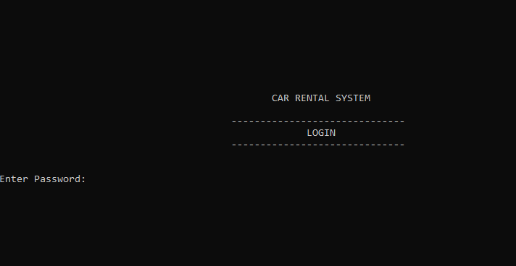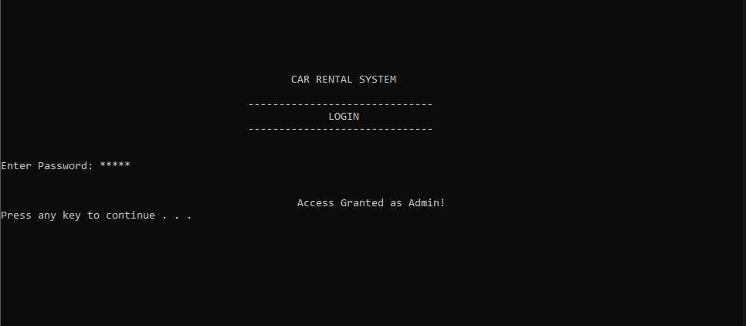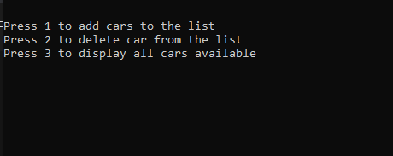

**

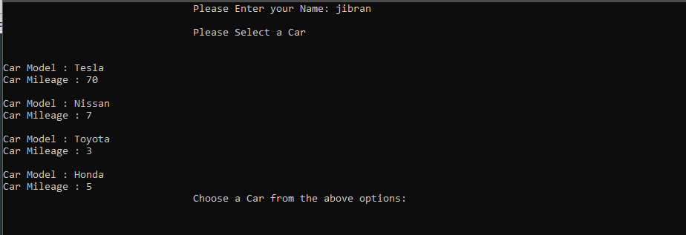

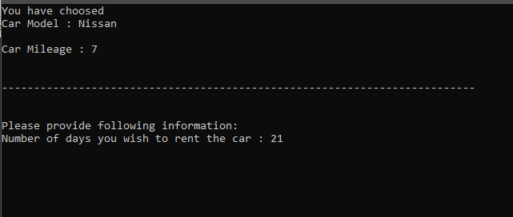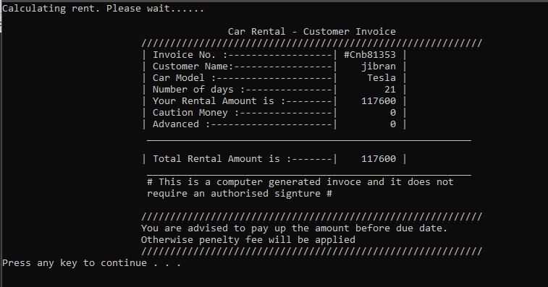

Chapter 8: **Conclusion**

Unveiling a New Era of Car Rental: A Technological Leap Powered by C++ and Advanced Data Structures

In the ever-evolving realm of mobility services, the car rental industry stands poised for a transformative shift, driven by a groundbreaking technological innovation – the development of a next-generation car rental app built upon the robust foundation of C++ programming language and cutting-edge data structures. This remarkable advancement marks a paradigm shift in the industry, promising to revolutionize the way customers experience car rentals and empower car rental companies to operate with unprecedented efficiency and data-driven insights.

The decision to employ C++ as the programming language for this app is a testament to its unparalleled performance and versatility. Renowned for its speed, reliability, and memory management capabilities, C++ stands as the ideal choice for developing applications that demand exceptional performance and resource optimization – quintessential attributes for a car rental app that handles real-time data processing, complex transaction management, and seamless user interactions.

Complementing the power of C++ are the advanced data structures that underpin the app's functionality. These meticulously selected data structures, such as linked lists, hash tables, and trees, provide the foundation for efficient data storage, retrieval, and manipulation. Their inherent strengths enable the app to handle large volumes of car rental data with remarkable speed and accuracy, ensuring that customers can effortlessly navigate the app, browse car options, and complete rental transactions with minimal latency.

The significance of this technological leap extends far beyond its technical prowess. The app represents a transformative force with the potential to revolutionize the entire car rental industry, addressing the shortcomings of traditional systems and ushering in a new era of efficiency and convenience. Traditional car rental processes often suffer from cumbersome booking procedures, outdated inventory management systems, and a lack of personalization, leading to customer frustration and operational inefficiencies. This innovative app tackles these challenges head-on, introducing a streamlined booking process that allows customers to secure their rental cars in a matter of clicks.

The app's impact extends to car rental companies as well, offering them a powerful tool for strategic decision-making. The integration of advanced data structures, coupled with real-time analytics capabilities, provides companies with unprecedented insights into customer behavior, rental trends, and market dynamics. Armed with this data-driven intelligence, companies can make informed decisions regarding fleet management, pricing strategies, and marketing campaigns, enabling them to optimize their operations and stay ahead of the competition.

This optimization extends beyond decision-making to the very core of operations. Automation of booking and payment processes streamlines day-to-day activities, reducing costs and minimizing the risk of errors. Efficient inventory management, guided by real-time availability insights, ensures that the fleet is utilized optimally, preventing overbooking or underutilization of vehicles. Maintenance scheduling is likewise optimized, contributing to a positive brand image and reducing unexpected disruptions for customers.

The app's impact extends beyond operational efficiency, revolutionizing the customer experience. Personalized recommendations, powered by machine learning algorithms, suggest car options tailored to individual preferences, while dynamic pricing strategies ensure that customers receive competitive rates based on real-time market conditions. This personalized approach fosters customer loyalty and satisfaction, positioning car rental companies as leaders in the evolving car rental market.

As the car rental landscape undergoes continuous transformation, this app emerges as a beacon of innovation. It is not merely a technological upgrade but a pioneering force shaping the future of mobility. The app's capabilities position it at the forefront of the industry, adapting to changing customer expectations and market trends. It becomes more than just a tool for renting cars; it becomes a key player in redefining how people experience and interact with mobility services.

The development of this next-generation car rental app using C++ and advanced data structures is not just a technical endeavor; it's a strategic move that holds the potential to reshape the car rental industry. It promises a future where customers enjoy a seamless, personalized, and efficient rental experience, while car rental companies leverage data-driven insights to navigate and lead in the dynamic and competitive market landscape. This app is not just a step forward; it's a leap into the future of mobility services.